



**Campaign Finance Guide**

**I. Key Campaign Finance Vocabulary**

* *Hard Money* – campaign contributions regulated and limited by the federal government that are given directly to a candidate
* *Soft Money – unlimited and unregulated campaign contributions to federal candidates and the national parties Supposedly for generic “party building” activities (ex: get-out-the-vote drives, bumper stickers, yard signs, and “issue ads”)*
* *Political Action Committee (PAC) –* officially registered fund-raising organization that represents interest groups in the political process.
* *527 Groups – Tax-exempt organizations created to raise money for political activities such as voter mobilization efforts and issue ads*
* *501c Groups – Nonprofit, tax-exempt interest groups that can engage in varying levels of political activity*
* *Super PACs - PACs may raise and spend unlimited sums of money in order to advocate for or against political candidates.*

**II. Important Campaign Finance Laws**

* *Tillman Act (1907) –* the first legislation in the United States prohibiting monetary contribution to national political campaigns by corporations.
* *Federal Election Campaign Act* (1971, 1974) – increased disclosure of [contributions for federal campaigns](http://en.wikipedia.org/wiki/Campaign_finance_in_the_United_States) and 1974 amendments placed legal limits on the campaign contributions.
* *Bipartisan Campaign Reform Act (a.k.a. McCain-Feingold Act)*  – banned national parties and officeholders from raising and spending “soft money,” and prohibited corporations and unions from funding "electioneering communications” within 30 days before a primary or 60 days before a general election.

**III. Campaign Finance Supreme Court Decisions**

* *Buckley v. Valeo* (1976) – candidates spending money to finance their own campaigns is a form of constitutionally protected free speech through the 1st Amendment
* *McConnell v. Federal Election Commission* (2003) - upheld most of BCRA ruling that restrictions on free speech justified by government’s interest to prevent corruption in campaigns
* *Citizens United v. Federal Election Commission* (2010) – ruled spending is protected speech under the 1st Amendment and the government cannot prohibit spending by corporations and labor unions to support or denounce individual candidates in elections

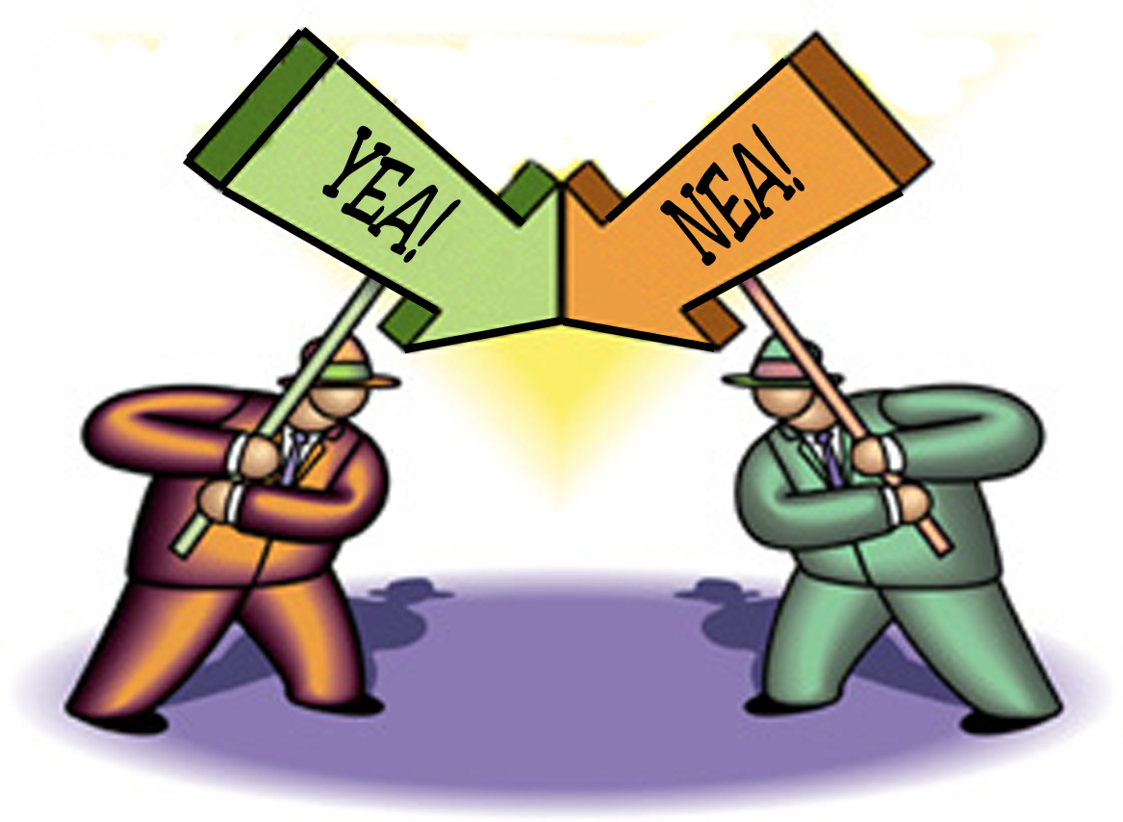

**Does *Citizen United v. F.E.C.* Threaten Democracy?**

**Open Forum**

**Directions:**

In 2010, the U.S. Supreme Court ruled in *Citizens United v. F.E.C.* that political spending by corporations and labor unions is a form of protected speech under the first amendment. This decision has sparked great debate over the appropriate application of the First Amendment and the inherent fairness of unlimited money injected into political campaigns. This activity requires you to consider the pro’s and con’s of the *Citizen United* decision. You will use sources like the majority and dissenting opinions of the U.S. Supreme Court, relevant articles and video clips to build your argument for the open forum. The class will be divided into two large teams, pro and con, to prepare for and then debate the following sides:

**Side A [Pro]: *Citizen United* protects our First Amendment right of free speech.**

**Versus**

**Side B [Con]: *Citizens United* threatens democracy.**

**Open Forum:**

Each student will be assigned to one side of the argument: in favor of the Electoral College

system or against it. You personal feelings about this topic are irrelevant for the purpose of this

activity!!!!!

1. Preparation (30-45 minutes) – The class will be divided into both large pro or con teams, and subgroups with that. Each small group will brainstorm as many arguments as possible to support its position. The group will then choose a leader who will argue the groups class in the formal debate.
2. Opening Statements (3-4 minutes per team) – Each group presents its side and supporting arguments.
3. Rebuttal (open to the whole class) – The debate is then opened up to all participants with the following ground rules:
4. No person may speak twice until everyone has spoken once.
5. Sides will alternate comments (if pro person speaks a con person must go next).
6. The speaker will choose the next person.

**Assessment:**

At the end of class, each student will be given a grade based on the quality of her/his participation in the open forum (see attached Open Forum Assessment Rubric)

**Open Forum Assessment Rubric**

**Participant’s Name: __________________________________________________ Date: __________________________**

**Debate Topic: ________________________________________________________________________________________**

 **Grade =**

**Grading Rubric: 5 = A+ - A; 4 = A- -B+; 3 = B - B-; 2 = C+ - C; 1 = C- - D-; 0 = F**

**5** Demonstrates superior knowledge of assigned side of the issue, as well as understanding of the other side; uses numerous specific details, examples and evidence from the relevant sources; very effectively applies outside information and insight to the discussion; shows outstanding analytical skills; exhibits very high degree of focus on the task at hand.

**4** Demonstrates very good knowledge of assigned side of the issue; uses a number details, specific examples and evidence from relevant sources; effectively applies outside information and insight to the discussion; shows very good analytical skills; exhibits a high degree of focus on the task at hand.

**3** Demonstrates knowledge of assigned side of the issue; uses some details and specific examples and evidence from the article as well as outside information; applies outside information and insight to the discussion; shows good analytical skills; exhibits good degree of focus on the task at hand.

**2** Demonstrates general knowledge of assigned issue; uses relatively few details and specific examples; applies little outside information and insight to the discussion; shows fair analytical skills; somewhat unfocused on the task at hand.

**1** Little knowledge of content demonstrated; unprepared; very little participation.

**0** Did not participate

**Feedback and Comments:**

***Citizen United v. F.E.C.* Open Forum**

**Source Analysis Graphic Organizer**

Student Handout

Directions – As you read through your sources in preparation for the open forum, record important pieces of evidence that support each side, and identify key points you want to make during the debate. HINT: be sure that you anticipate arguments from the other side.

|  |  |  |  |
| --- | --- | --- | --- |
| **Source** | **Evidence Supporting Side A** | **Evidence Supporting Side B** | **Key Debate or Rebuttal Points** |
|  |  |  |  |
|  |  |  |  |
|  |  |  |  |

|  |  |  |  |
| --- | --- | --- | --- |
| **Source** | **Evidence Supporting Side A** | **Evidence Supporting Side B** | **Key Debate or Rebuttal Points** |
|  |  |  |  |
|  |  |  |  |
|  |  |  |  |

**Political Cartoon #1**

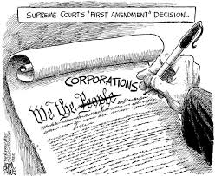

**Title: The Supreme Court’s “First Amendment Decision**

**Artist: Adam Zyglis, *The Buffalo News* Date: 10/28/10**

**Source:** <http://theragblog.blogspot.com/2010/10/david-p-hamilton-citizens-united-and.html>

1. Describe what’s going on in the political cartoon (Who? What? When? Where?).
2. Identify any symbols (ex: an elephant to represent the Republican Party) portrayed in the cartoon and analyze what they represent.
3. What is the artist’s message in the cartoon? What do you think?
4. Explain what this cartoon tells us about special interest money in political campaigns after the Citizens United decision.

**Political Cartoon #2**

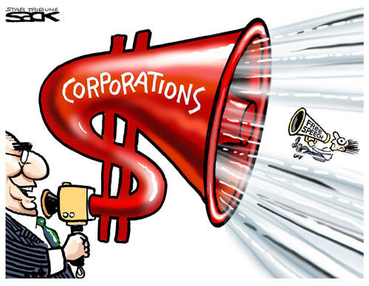

**Title: Corporations and Free Speech**

**Artist: Steve Sack, *Minneapolis Star-Tribune* Date: 1/17/12**

**Source:** <http://jobsanger.blogspot.com/2012/01/can-brown-warren-keep-special-interest.html>

1. Describe what’s going on in the political cartoon (Who? What? When? Where?).
2. Identify any symbols (ex: an elephant to represent the Republican Party) portrayed in the cartoon and analyze what they represent.
3. What is the artist’s message in the cartoon? What do you think?
4. Explain what this cartoon tells us about special interest money in political campaigns after the Citizens United decision.

**Political Cartoon #3**

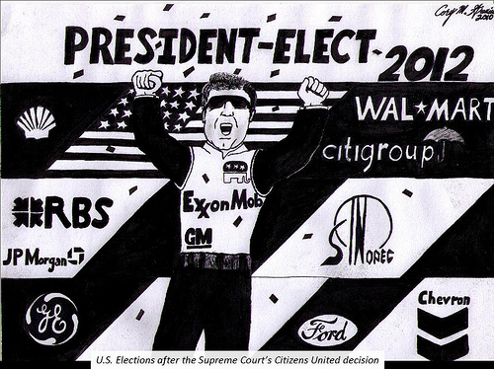

**Title: U.S. Elections after the Supreme Court’s *Citizens United* decision**

**Artist: Sean *Siperstein* Date: 11/4/11**

**Source:** [**http://www.citizenvox.org/2011/11/04/the-limits-of-free-speech-citizens-united-vs-occupy-wall-street/cu-cartooon/**](http://www.citizenvox.org/2011/11/04/the-limits-of-free-speech-citizens-united-vs-occupy-wall-street/cu-cartooon/)

1. Describe what’s going on in the political cartoon (Who? What? When? Where?).
2. Identify any symbols (ex: an elephant to represent the Republican Party) portrayed in the cartoon and analyze what they represent.
3. What is the artist’s message in the cartoon? What do you think?
4. Explain what this cartoon tells us about special interest money in political campaigns after the Citizens United decision.

**Political Cartoon #4**

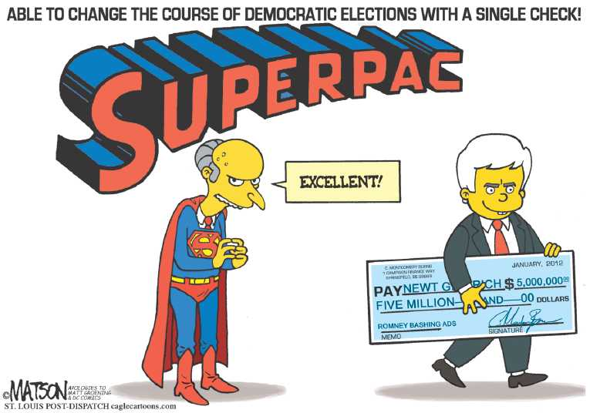

**Title: Able to Change the Course of Democratic Elections with a Single Check**

**Artist: RJ Matson, *St. Louis Post-Dispatch* Date: 1/18/12**

**Source:** <http://thecomicnews.com/edtoons/2012/0118/pacs/01.php>

1. Describe what’s going on in the political cartoon (Who? What? When? Where?).
2. Identify any symbols (ex: an elephant to represent the Republican Party) portrayed in the cartoon and analyze what they represent.
3. What is the artist’s message in the cartoon? What do you think?
4. Explain what this cartoon tells us about special interest money in political campaigns after the Citizens United decision.

**Political Cartoon #5**

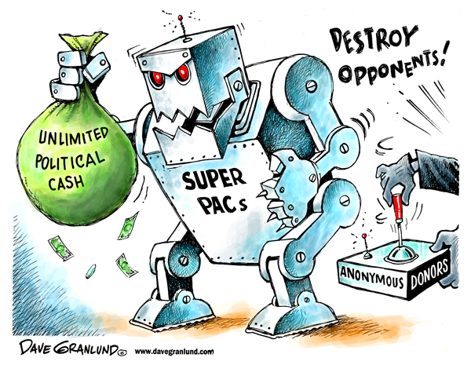

**Title: Super PACs the New Political Machine**

**Artist: Dave Granlund Date: 9/12/12**

**Source:** <http://unitedrepublic.org/august-goes-obama-autumn-goes-pacs/>

1. Describe what’s going on in the political cartoon (Who? What? When? Where?).
2. Identify any symbols (ex: an elephant to represent the Republican Party) portrayed in the cartoon and analyze what they represent.
3. What is the artist’s message in the cartoon? What do you think?
4. Explain what this cartoon tells us about special interest money in political campaigns after the Citizens United decision.