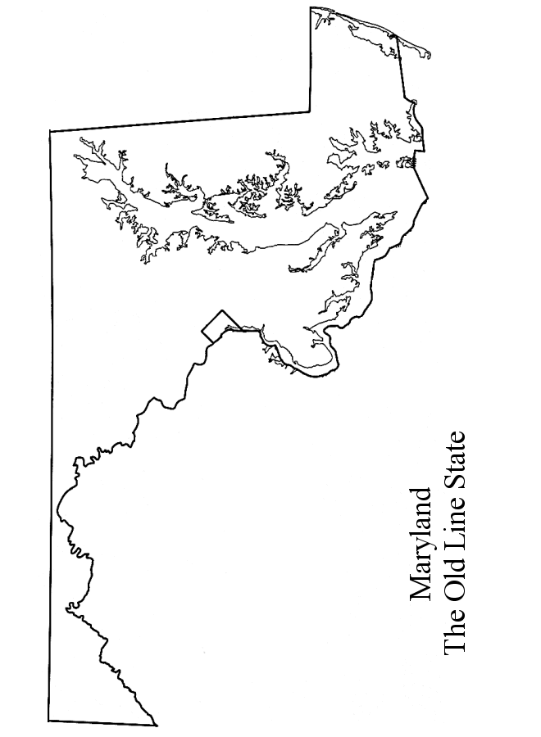

**Gerrymander Maryland**

Congratulations! You have been appointed by the Governor of Maryland to design the new congressional district map for Maryland based on the most recent census. As you know, we have eight seats in the House of Representatives that represent the 5,900,000 people currently living in the state.

The map has 56 stars on it. Each star represents 100,000 people. The black stars represent an area where more voters are registered as Democrats The white stars represent an area where more voters are registered as Republicans.

Your job as a ____________________ is to try to get your political party the most seats possible for the next election. Circle and label the eight districts. Each district has to have EXACTLY eight stars but there are no restrictions on how to draw them.