- Editorial cartoonists know what will capture the mind's attention first. Allow your mind and eyes to naturally find the portion of the cartoon that most stands out. Most often, this will be a caricature, which is an exaggeration or distortion of a person or object with the goal of providing a comic effect.
- Follow the cartoon's natural flow by discovering the interaction with the primary focus (found in step 1). If it's a person, who are they talking to? Where are they standing? If it's an object, what is being done to the object? What is it doing there? Most often, you can look around the immediate vicinity of the primary focus to find what is being described. This is usually an allusion, or an indirect reference to a past or current event that isn't explicitly made clear within the cartoon.
- Determine the audience. What section of the population is the publication geared towards, and in what country and/or locality? A political cartoon will be created with consideration to the experiences and assumptions of the intended audience. For example, a political cartoon in a publication distributed in a strictly conservative town will convey its message in a different way than it would if the audience was a particularly liberal group.
- Understand the context of the cartoon. More often than not, the political cartoon will be published in context, meaning that it is associated with the main news story of the day. If you are viewing a political cartoon outside of its original publishing source, you will want to be well-read about current and historical events.
- Look for widely recognized symbols. Some metaphors are commonly used by political cartoonists.
- Look at minor details in the cartoon that will contribute to the humor or the point of the cartoon. Often, words or pictorial symbols will be used to convey minor themes or ideas, but they are found in the background or on the sides of the cartoon.
- NOTE: In most cases, the question associated with the political cartoon will require you to be able to apply the main idea of the cartoon. BEFORE looking at any of the possible answers, determine what the main idea/focus of the cartoon is. If you can determine this, you will be able to answer the question easily and in little time.

- LET’S SEE HOW YOU DO WITH THE 4 CARTOONS THAT APPEAR ON THE NEXT PAGE: IN THE MARGINS WRITE DOWN THE MAIN IDEA FOR EACH, NOTING THE FOCUS, SUBJECT, AUDIENCE, CONTEXT, SYMBOLS, MINOR DETAIL.

#1
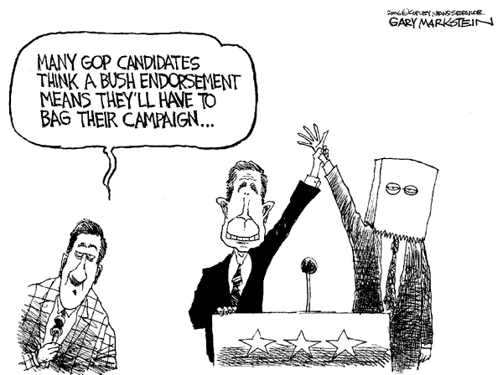
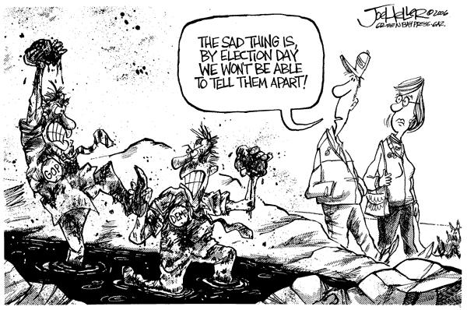
#2

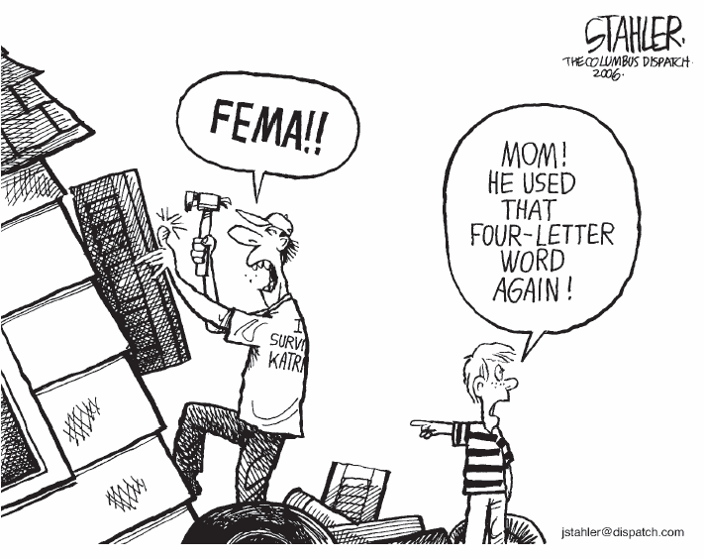
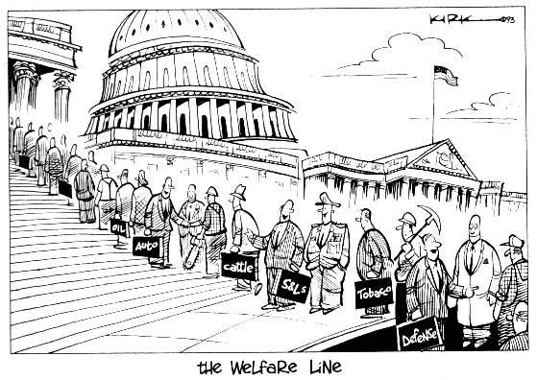
#3
#4

