Primary Documents Detective Game II 

You have studied the political writings of John Locke, Thomas Hobbes, Baron de Montesquieu, Jean-Jacques Rousseau, and William Blackstone. Using this knowledge you will work in a group to uncover their ideas of government and law in three important United States documents: the Virginia Constitution, the Declaration of Independence, and the U.S. Constitution. Your group will analyze the three documents and identify specific concepts these political thinkers advocated by choosing from the word bank below.

Note: there may be more than one political thinker or concept for each selection.

Concepts of Democracy

Consent of the Governed Equality under the law

Inalienable Rights Limited government Rule of Law

Natural Rights Republican Government

Separation of Powers Social contract

Virginia Constitution

Article I, Section 1
Equality and rights of men.

Political Thinker________________________ Concept___________________

Section 2
People the source of power.

Political Thinker________________________ Concept___________________

Section 3
Government instituted for common benefit.

Political Thinker________________________ Concept___________________

Section 6
Free elections; consent of governed.

Political Thinker________________________ Concept___________________

Article III, Section 1
The legislative, executive, and judicial departments shall be separate and distinct, so that none exercise the powers properly belonging to the others, nor any persons exercise the power of more than one of them at the same time…

Political Thinker__________________________ Concept___________________

The Declaration of Independence

Paragraph 1
When in the course of human events, it becomes necessary for one people to dissolve the political bands which have connected them with one another, and to assume among the powers of the earth, the separate and equal station to which the Laws of Nature and of Nature’s God entitle them, a decent respect to the opinions of mankind requires that they should declare the causes which impel them to the separation.

Political Thinker_________________________ Concept___________________

Paragraph 2
We hold these truths to be self-evident, that all men are created equal, that they are endowed by their Creator with certain unalienable Rights, that among these are Life, Liberty and the pursuit of Happiness.

Political Thinker_________________________ Concept___________________

Paragraph 2
That to secure these rights, Governments are instituted among Men, deriving their just powers from the consent of the governed.

Political Thinker________________________ Concept___________________

The United States Constitution

Article I, Section 2
The House of Representatives shall be composed of Members chosen every second Year by the People of the several States, and the Electors in each State shall have the Qualifications requisite for Electors of the most numerous Branch of the State Legislature.

Political Thinker________________________ Concept___________________

Article IV, Section 4
The United States shall guarantee to every State in this Union a Republican Form of Government, and shall protect each of them against Invasion; and on Application of the Legislature, or of the Executive against domestic Violence.

Political Thinker________________________ Concept___________________

Article VI
This Constitution, and the Laws of the United States which shall be made in Pursuance thereof; and all Treaties made, or which shall be made, under the Authority of the United States, shall be supreme Law of the Land; and the Judge in every State shall be bound thereby, any Thing in the Constitution or Laws of any State to the Contrary notwithstanding.

Political Thinker________________________ Concept___________________

Four Political Philosophers

Thomas Hobbes

John Locke

Baron de Montesquieu

Jean Jacques Rousseau

George Giusti - 1955

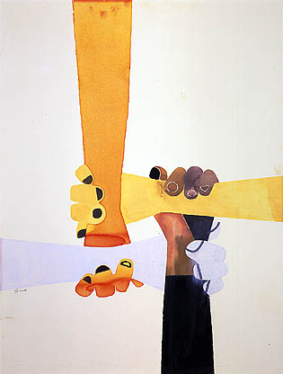

Civilization is a Method of Living, An Attitude of Equal Respect for All Men
- Jane Addams, 1933

Social Contract is the idea that people join groups, and these groups make a presence known as a society. A social contract is the compact that the people agree form rules and conditions for membership in their society.

Equality is the belief that all persons are entitled to equal rights and treatment before the law.

Questions to Consider:
- How does this picture represent a social contract?
- In what ways do people form social contracts today?
- Do you believe that people receive equal treatment before the law? Why or why not?

Astronaut and U.S. flag on the Moon

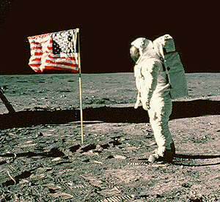

Apollo 11 astronaut Edwin “Buzz” Aldrin stands facing the U.S. flag on the Moon. The rod to hold the flag out horizontally would not extend fully, so the flag ended up with a slight waviness, giving the appearance of being windblown. The flag itself was difficult to erect, it was very hard to penetrate beyond about 6 to 8 inches into the lunar soil with the flagstaff.

Civil Society occurs after people leave the state of nature. Signs of this transfer are: people act on rules of justice rather than on instinct, physical impulse is replaced by the voice of duty, and people consult reason rather than inclinations. By entering civil society people gain civil liberty and the legal right of property in what he possess. They also gain moral freedom, making people masters of themselves.

Question to consider:
- What is the relationship between Rousseau’s thoughts on civil society and this image?

For My People
~Margaret Walker

For my people everywhere singing their slave songs repeatedly: their dirges and their ditties and their blues and jubilees, praying their prayers nightly to an unknown god, bending their knees humbly to an unseen power;

For my people lending their strength to the years, to the gone years and the now years and the maybe years, washing ironing cooking scrubbing sewing mending hoeing plowing digging planting pruning patching dragging along never gaining never reaping never knowing and never understanding;

For my playmates in the clay and dust and sand of Alabama backyards playing baptizing and preaching and doctor and jail and soldier and school and mama and cooking and playhouse and concert and store and hair and Miss Choomby and company;

For the cramped bewildered years we went to school to learn to know the reasons why and the answers to and the people who and the places where and the days when, in memory of the bitter hours when we discovered we were black and poor and small and different and nobody cared and nobody wondered and nobody understood;

For the boys and girls who grew in spite of these things to be man and woman, to laugh and dance and sing and play and drink their wine and religion and success, to marry their playmates and bear children and then die of consumption and anemia and lynching;

For my people thronging 47th Street in Chicago and Lenox Avenue in New York and Rampart Street in New Orleans, lost disinherited dispossessed and happy people filling the cabarets and taverns and other people's pockets needing bread and shoes and milk and land and money and something--something all our own;

For my people walking blindly spreading joy, losing time being lazy, sleeping when hungry, shouting when burdened, drinking when hopeless, tied, and shackled and tangled among ourselves by the unseen creatures who tower over us omnisciently and laugh;

For my people blundering and groping and floundering in the dark of churches and schools and clubs and societies, associations and councils and committees and conventions, distressed and disturbed and deceived and devoured by money-hungry glory-craving leeches, preyed on by facile force of state and fad and novelty, by false prophet and holy believer;

For my people standing staring trying to fashion a better way from confusion, from hypocrisy and misunderstanding, trying to fashion a world that will hold all the people, all the faces, all the adams and eves and their countless generations;

Let a new earth rise. Let another world be born. Let a bloody peace be written in the sky. Let a second generation full of courage issue forth; let a people loving freedom come to growth. Let a beauty full of healing and a strength of final clenching be the pulsing in our spirits and our blood. Let the martial songs be written, let the dirges disappear. Let a race of men now rise and take control.

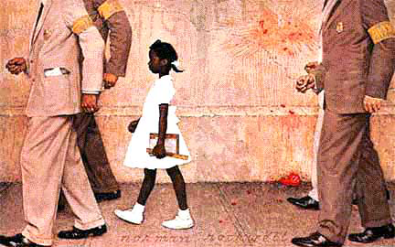
The Problem We All Live With
by Norman Rockwell

“The state of nature has a law of nature to govern it, which treats everyone equally…[B]eing equal and independent, no one ought to harm another in his life, health, or possessions.”
-John Locke

Unalienable rights are rights that cannot be taken away from anyone, for example freedom of speech.

Equal rights are the belief that all persons, regardless of sex, race, ethnicity, age, etc., have the same rights as everyone else.

Questions to consider:
- What is happening in this painting?
- Which principles of democracy are illustrated by this painting?
(equality, natural rights, liberty, unalienable rights)

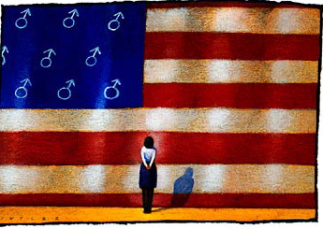

Flag with Male Symbol
By Dave Cutler

“The old [traditions] are apt to lead men into mistakes, as this [idea] of [fatherly] power’s probably has done, which seems so [eager] to place the power of parents over their children wholly in the father, as if the mother has no share in it. Whereas if we consult reason or [the Bible], we shall find she has an equal title.”
-John Locke

Unalienable rights are rights that cannot be taken away from anyone, for example freedom of speech.

Equal rights are the belief that all persons, regardless of sex, race, ethnicity, age, etc., have the same rights as everyone else.

Questions to Consider:
- What is happening in this painting?
- How does this painting relate to the concept of unalienable rights? Equal rights?

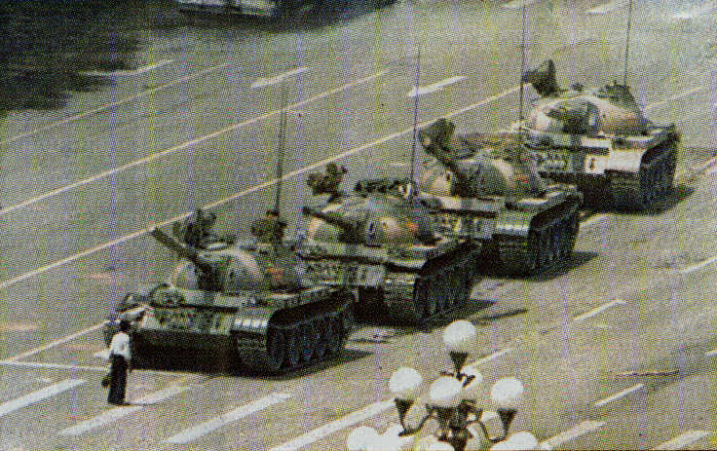

June 1989 – Tiananmen Square
Photographer: Unknown

“Whensoever…the [government]shall…put into the hands of any other an absolute power over the lives, liberty, and estates of the people, by this breach of trust they forfeit the power [of] the people…who have a right to resume their original liberty, and by the establishment of the new [government] provide for their own safety and security.”
-John Locke

A limited government is a government that does not have absolute authority.

Consent of the governed is the political theory that governments gain their authority from their people. A government is not legitimate if the people do not give their consent.

Question to consider:
- What is happening in the picture and how does it relate to the topic of limited government?
Study Guide: A Key to John Locke

Please read the following excerpts taken from John Locke’s Second Treatise on Government and then re-write them in your own words. Finally, circle the number on a scale of 1 to 5 corresponding with how much you agree or disagree with Mr. Locke’s quote.

- “The state of nature has a law of nature to govern it, which treats everyone equally. …[B]eing equal and independent, no one ought to harm another in his life, health or possessions”.

1 2 3 4 5
disagree neutral agree

- “We have reason to conclude that all peaceful beginnings of government have been laid in the consent of the people.”

1 2 3 4 5
disagree neutral agree

- “The old [traditions] are apt to lead men into mistakes, as this [idea] of [fatherly] power’s probably has done, which seems so [eager] to place the power of parents over their children wholly in the father, as if the mother has no share in it. Whereas if we consult reason or [the Bible], we shall find she has an equal title.”

1 2 3 4 5
disagree neutral agree

- “Whensoever...the [government] shall…put into the hands of any other an absolute power over the lives, liberties, and estates of the people, by this breach of trust they forfeit the power [of] the people…who have a right to resume their original liberty, and by the establishment of the new [government] provide for their own safety and security.”

1 2 3 4 5
disagree neutral agree

John Locke Biography

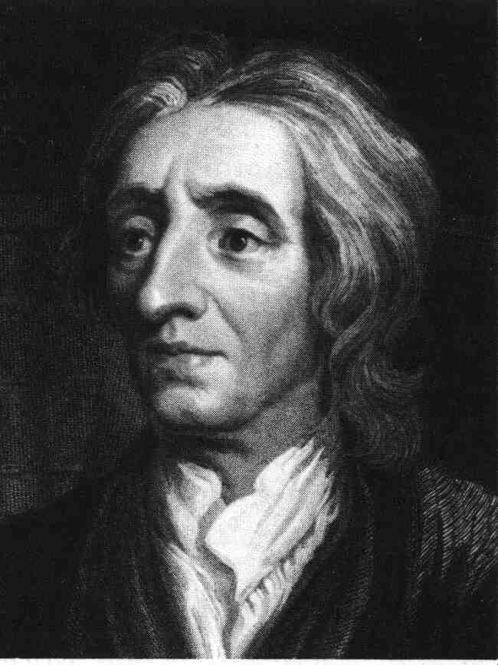
John Locke

John Locke was born in Bristol, England, on August 29, 1632. Locke's father was an attorney who collected taxes from seaport towns. He wanted his son to become a minister, but Locke rejected this and studied medicine. Locke entered Oxford University in England and was influenced by John Owen, Dean of Christ Church College. It was Owen who first introduced Locke to the idea of religious freedom and the idea that people should not be punished for having different views of religion. Locke believed that all sides had the right to be heard. Moreover, he felt that all conflicts could be solved if the two could settle their differences by seeking a middle ground and compromise.

John Locke wrote two treatises of government in 1690. In these treatises he said that the government should be like a contract or agreement between the people and the ruler. The ruler is given the power to govern the country as long as he doesn't abuse his position. In brief, Locke argued that sovereignty did not reside in the state but with the people, and that the state is supreme, but only if it is bound by civil and what he called "natural" law. If the ruler didn't keep the contract, the people could overthrow the government. Locke also believed that the people were entitled to natural rights such as life, liberty and the protection of their property. Many of Locke's political ideas, such as those relating to natural rights, property rights, the duty of the government to protect these rights, and the rule of the majority, were later embodied in the U.S. Constitution.

Excerpted from: http://www.rjgeib.com/thoughts/constitution/locke-bio.html
Extended Biography
http://www.rjgeib.com/thoughts/constitution/locke-bio.html
(This site provides thorough background information on John Locke, but the web address referenced in the “Procedures” section of this packet is a better choice for additional student research.)

After college, Locke continued to study and read with passion. He expressed his views about freedom of religion and the rights of citizens. In 1682 his ideas were seen by the English government as a challenge to the king's authority. He fled to Holland, and then returned to England in 1689 after the Civil War in England. Shortly thereafter, Locke began publishing his writings, many of which focused on government. Throughout his writings, Locke argued that people had the gift of reason, or the ability to think. Locke thought they had the natural ability to govern themselves and to look after the well being of society. He wrote, "The state of nature has a law of nature to govern it, which [treats] everyone [equally]. Reason, which is that law, teaches all mankind... that being all equal and independent, no one ought to harm another in his life, health or possessions."
Locke did not believe that God had chosen a group or family of people to rule countries. He rejected the "Divine Right," which many kings and queens used to justify their right to rule. Instead, he argued that governments should only operate with the consent of the people they are governing. In this way, Locke supported democracy as a form of government. Locke wrote, "[We have learned from] history we have reason to conclude that all peaceful beginnings of government have been laid in the consent of the people." Governments were formed, according to Locke, to protect the right to life, the right to freedom, and the right to property. Their rights were absolute, belonging to all the people. Locke also believed that government power should be divided equally into three branches of government so that politicians will not face the "temptation... to grasp at [absolute] power." If any government abused these rights instead of protecting them, then the people had the right to rebel and form a new government.
John Locke spoke out against the control of any man against his will. This control was acceptable neither in the form of an unfair government, nor in slavery. Locke wrote, “The natural liberty of man is to be free from any superior power on earth, and not to be under the will or legislative authority of man, but only have the law of nature for his rule." In addition, Locke felt that women had the ability to reason, which entitled them to an equal voice - an unpopular idea during this time in history. Despite fearing that he might be censored, he wrote, "It may not be [wrong] to offer new... [ideas] when the old [traditions] are apt to lead men into mistakes, as this [idea] of [fatherly] power's probably has done, which seems so [eager] to place the power of parents over their children wholly in the father, as if the mother had no share in it. Whereas if we consult reason or (the Bible), we shall find she has an equal title.”

Excerpts from John Locke’s
Second Treatise on Government
(1632-1704)

CHAPTER IV
Of Slavery

21. The natural liberty of man is to be free from any superior power on Earth, and not be under the will or legislative authority of man, but to have only the law of Nature not to be tied by any laws”; but freedom of men under government is to have a standing rule to live by, common to every one of that society, and made by the legislative power erected in it. A liberty to follow my own will in all things where that rule prescribes not, not to be subject to the inconstant, uncertain, unknown, arbitrary will of another man, as freedom of nature is to be under no other restraint but for his rule. The liberty of man in society is to be under no other legislative power but that established by consent in the commonwealth, nor under the dominion of any will, or restrain of any law, but what the legislative shall enact according to the trust put in it. Freedom, then, is not what Sir Robert Filmer tells us: “A liberty for every one to do what he lists, to live as he pleases, and the law of Nature.

22. This freedom from absolute, arbitrary power is so necessary to, and closely joined with, a man’s preservation, that he cannot part with but by what forfeits his preservation and life together. For a man, not having the power of his own life, cannot by compact or his own consent enslave himself to anyone, nor put himself under the absolute, arbitrary power of another to take away his life when he pleases. Nobody can give more power than he has himself, and he that cannot take away his own life cannot give another power over it. Indeed, having by his fault forfeited his own life by some act that deserves death, he to whom he has forfeited it may when he has him in his power, delay to take it, and
make use of him to his own service; and he does him no more injury by it. For, whenever he finds the hardship of his slavery outweigh the value of his own life, it is in power, by resisting the will of his master, to draw on himself the death he desires.

- This is the perfect condition of slavery, which is nothing else but the state of war continued between a lawful conqueror and a captive, for if once compact enter between them, and make an agreement for a limited power on the other side, and obedience on the other, the state of war and slavery ceases as long as the compact endures; for, as has been said, no man can by agreement pass over to another that which he hath not in himself – a power over his own life.

Excerpts from John Locke’s
Second Treatise on Government

CHAPTER X
Of the Forms of a Common-wealth

Sec. 132. THE majority having, as has been shewed, upon men's first uniting into society, the whole power of the community naturally in them, may employ all that power in making laws for the community from time to time, and executing those laws by officers of their own appointing; and then the form of the government is a perfect democracy: or else may put the power of making laws into the hands of a few select men, and their heirs or successors; and then it is an oligarchy: or else into the hands of one man, and then it is a monarchy: if to him and his heirs, it is an hereditary monarchy: if to him only for life, but upon his death the power only of nominating a successor to return to them; an elective monarchy. And so accordingly of these the community may make compounded and mixed forms of government, as they think good. And if the legislative power be at first given by the majority to one or more persons only for their lives, or any limited time, and then the supreme power to revert to them again; when it is so reverted, the community may dispose of it again anew into what hands they please, and so constitute a new form of government: for the form of government depending upon the placing the supreme power, which is the legislative, it being impossible to conceive that an inferior power should prescribe to a superior, or any but the supreme make laws, according as the power of making laws is placed, such is the form of the common-wealth.

Excerpts from John Locke’s
Second Treatise on Government

CHAPTER XI
Of the Legislative, Executive, and Federative Power of the Common-wealth

Sec. 143. THE legislative power is that, which has a right to direct how the force of the common-wealth shall be employed for preserving the community and the members of it. But because those laws which are constantly to be executed, and whose force is always to continue, may be made in a little time; therefore there is no need, that the legislative should be always in being, not having always business to do. And because it may be too great a temptation to human frailty, apt to grasp at power, for the same persons, who have the power of making laws, to have also in their hands the power to execute them, whereby they may exempt themselves from obedience to the laws they make, and suit the law, both in its making, and execution, to their own private advantage, and thereby come to have a distinct interest from the rest of the community, contrary to the end of society and government: therefore in well ordered commonwealths, where the good of the whole is so con sidered, as it ought, the legislative power is put into the hands of divers persons, who duly assembled, have by themselves, or jointly with others, a power to make laws, which when they have done, being separated again, they are themselves subject to the laws they have made; which is a new and near tie upon them, to take care, that they make them for the public good. . 144. But because the laws, that are at once, and in a short time made, have a constant.

Sec. 144. But because the laws, that are at once, and in a short time made, have a constant and lasting force, and need a perpetual execution, or an attendance thereunto; therefore it is necessary there should be a power always in being, which should see to the execution of the laws that are made, and remain in force. And thus the legislative and executive power come often to be separated.

Sec. 145. There is another power in every common-wealth, which one may call natural, because it is that which answers to the power every man naturally had before he entered into society: for though in a common-wealth the members of it are distinct persons still in reference to one another, and as such as governed by the laws of the society; yet in reference to the rest of mankind, they make one body, which is, as every member of it before was, still in the state of nature with the rest of mankind. Hence it is, that the controversies that happen between any man of the society with those that are out of it, are managed by the public; and an injury done to a member of their body, engages the whole in the reparation of it. So that under this consideration, the whole community is one body in the state of nature, in respect of all other states or persons out of its community.

Excerpts from John Locke’s
Second Treatise on Government

CHAPTER XV
Of Paternal, Political, and Despotical Power, Considered Together

Sec. 172. Thirdly, Despotical power is an absolute, arbitrary power one man has over another, to take away his life, whenever he pleases. This is a power, which neither nature gives, for it has made no such distinction between one man and another; nor compact can convey: for man not having such an arbitrary power over his own life, cannot give another man such a power over it; asting force, and need a perpetual execution, or an attendance thereunto; therefore it is necessary there should be a power always in being, which should see to the execution of the laws that are made, and remain in force. And thus the legislative and executive power come often to be separated.

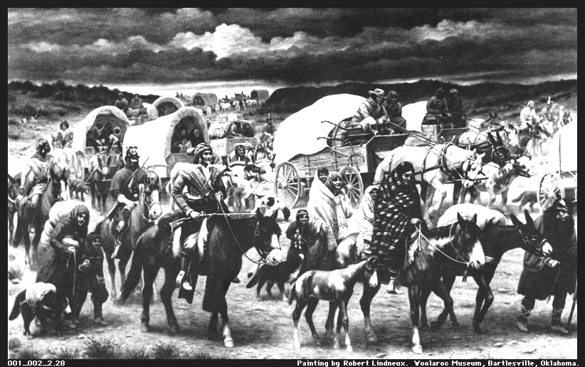
The Trail of Tears

By Robert Lindneux

Limited Government is the philosophy that government does not have absolute authority. Hobbes did not believe that that there should be many limits on government, but he did not think that a sovereign could do anything that would injure his or her subjects.

Questions to consider:
- What image is the artist trying to portray in this picture?
- Whose rights are being violated and why?
- Who is responsible for the “trail of tears”?
- What is the relationship between the “trail of tears” and the idea of limited government?

Thomas Hobbes Biography

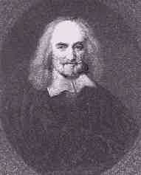
Thomas Hobbes
(This biography was excerpted from <www.rjgeib.com/thoughts/nature/hobbes-bio.html>)

Thomas Hobbes was born in London in 1588. He received his college education at Oxford University in England, where he studied classics. Hobbes traveled to other European countries several times to meet with scientists and to study different forms of government. During his time outside of England, Hobbes became interested in why people allowed themselves to be ruled and what would be the best form of government for England. In 1651, Hobbes wrote his most famous work, entitled Leviathan. In it, he argued that people were naturally wicked and could not be trusted to govern. Therefore, Hobbes believed that an absolute monarchy-a government that gave all power to a king or queen-was best.

Hobbes believed that humans were basically selfish creatures who would do anything to better their position. Left to themselves, he thought, people would act on their evil impulses. According to Hobbes, people therefore should not be trusted to make decisions on their own. In addition, Hobbes felt that nations, like people, were selfishly motivated. To Hobbes, each country was in a constant battle for power and wealth. To prove his point, Hobbes wrote, "If men are naturally in a state of war, why do they always carry arms and why do they have keys to lock their doors?"

Governments were created, according to Hobbes, to protect people from their own selfishness and evil. The best government was one that had the great power of a leviathan, or sea monster. Hobbes believed in the rule of a king because he felt a country needed an authority figure to provide direction and leadership.

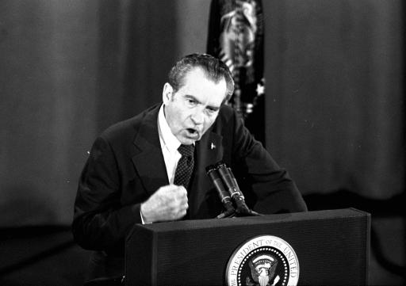
President Richard Nixon pounds his fist on the podium as he answers a question during his televised appearance before questioners made up of members of the National Broadcasters Association in Houston, Texas, March 19, 1974. President Nixon declared that dragging out Watergate drags down America. (AP Photo)

State of nature is the philosophy regarding how humans would act in their most basic state without a civil government. Hobbes believed the state of nature in which man lived before the formation of society was founded on a savage selfishness, which drove man to obtain pleasure without concern for justice or mercy toward other men.

Questions to consider:
- What event in history in does this image portray?
- Do you believe that this picture represents a man in a state of nature? Why or why not?


A Palestinian youth throws a tear gas canister back toward Israeli soldiers during clashes in the West Bank town of Ramallah Friday Feb. 16, 2001. Five months of fighting with Israel have emptied Yasser Arafat's public coffers and plunged the West Bank and Gaza Strip into a severe economic crisis, prompting unprecedented warnings by Israel and the United Nations that the Palestinian Authority may be headed for collapse. (AP Photo/Lefteris Pitarakis)

The state of war idea stems from Hobbes’ belief that in the state of nature, people were always at war with one another, a war of all against all. Each individual was endowed with the right to do anything they pleased and people were in constant fear for their lives.

Questions to consider:
- What is the conflict represented in this picture?
- Do you believe the fighting between the Israeli’s and the Palestinians illustrates a state of war?

Study Guide: Thomas Hobbes

Please read the following excerpts taken from Thomas Hobbes’ Leviathan and then rewrite them in your own words. Next, circle the number on a scale of 1 to 5 corresponding with how much you agree or disagree with Mr. Hobbes’ quote.

1. “For the laws of nature (as justice, equity, modesty, mercy, and in sum, doing to others as we would be done to) of themselves, without the terror of some power, to cause them to be observed, are contrary to our natural passions, that carry us to partiality, pride, revenge and the like”.

1 2 3 4 5
disagree neutral agree

2. “During the time men live without a common power to keep them all in awe, they are in that conditions called war; and such a war, as if of every man, against every man…To this war of every man against every man, this also in consequent; that nothing can be unjust. The notions of right and wrong, justice and injustice have there no place. Where there is no common power, there is no law, no injustice”.

1 2 3 4 5
disagree neutral agree

3. “The safety of the People, requireth further, from him, or them that have the Sovereign Power, that Justice be equally administered to all degrees of People, that is, that as well the rich and mighty, as poor and obscure persons, may be righted of the injuries done them . . . "
1 2 3 4 5
disagree neutral agree

4. “Unnecessary laws are not good laws, but traps for money.”
1 2 3 4 5
disagree neutral agree

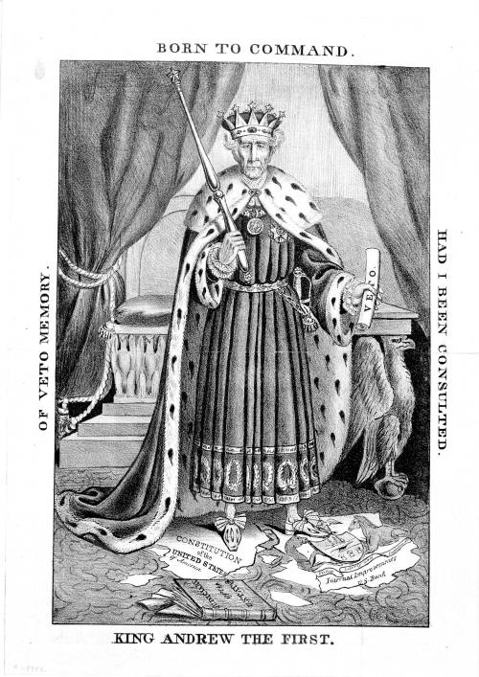

Wietenkampf

Separation of Powers is the principle of dividing the powers of a government among different branches to guard against abuse of authority. A government of separated powers assigns different political and legal powers to the legislative, executive, and judicial branches.

Questions to consider:
- What is the cartoonist trying to illustrate in this picture?
- Why is Andrew Jackson standing on the U.S. Constitution?
- How is President Jackson violating the philosophy of separation of powers in this cartoon?

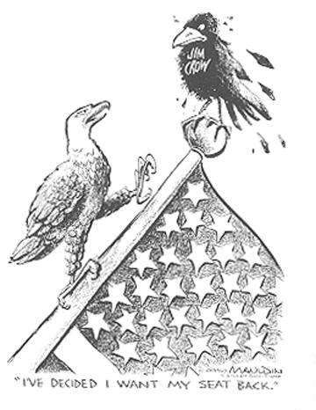
Bill Mauldin

Equality under the law is the belief that all people receive fair and equal protection by the government through written law.

Questions to consider:
- What is the cartoonist trying to illustrate in this picture?
- Why is it important that the bald eagle is trying to regain his position?
- How does this cartoon represent the belief in equality under the law?

Study Guide: Baron de Montesquieu’s On the Spirit of Laws

Please read the following excerpts taken from Baron de Montesquieu’s On the Spirit of Laws and then rewrite them in your own words. Next, circle the number on a scale of 1 to 5 corresponding with how much you agree or disagree with Mr. Montesquieu’s quote.

- “When the legislative and executive powers are united in the same person, or in the same body of magistrates, there can be no liberty; because apprehensions may arise, lest the same monarch or senate should enact tyrannical laws, to execute them in a tyrannical manner.

1 2 3 4 5
disagree neutral agree

- “The great advantage of representatives is, their capacity of discussing public affairs. For this the people collectively are extremely unfit, which is one of the chief inconveniences of a democracy.”

1 2 3 4 5
disagree neutral agree

- “In republican governments, men are all equal; equal they are also in despotic governments: in the former, because they are everything: in the latter, because they are nothing.”

1 2 3 4 5
disagree neutral agree

- In a true state of nature, indeed, all men are born equal, but they cannot continue in this equality. Society makes them lose it, and they recover it only by the protection of laws.”

1 2 3 4 5

disagree neutral agree

Baron de Montesquieu Biography

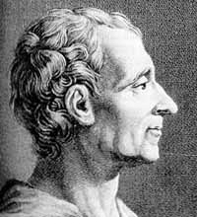
Charles de Secondat,
Baron de la Brede et de Montesquieu
(This biography was excerpted from <www.rjgeib.com/thoughts/montesquieu/montesquieu-bio.html>)

Charles Louis de Secondat was born in Bordeaux, France, in 1689 to a wealthy family. Despite his family’s wealth, he was placed in the care of a poor family during his childhood. De Secondat studied science and history in college, eventually becoming a lawyer in the local government. After his father’s death, he was placed under the care of his uncle, Baron de Montesquieu. When his uncle died, de Secondat acquired his title and his fortune.

Montesquieu’s book, On the Spirit of Laws, published in 1748, was his most famous work. It outlined his ideas on how government would best work. He believed that all things were made up of rules or laws that never changed. He set out to study these laws scientifically with the hope that knowledge of the laws of government would reduce the problems of society and improve human life. According to Montesquieu, there were three types of government: a monarchy (ruled by a king or queen), a republic (ruled by an elected leader), and a despotism (ruled by a dictator). Montesquieu believed that a government that was elected by the people was the best form of government. He argued that the best government would be one in which power was balanced among three groups of officials-and idea he called “separation of powers.” His ideas became the basis for the United States Constitution.

George Giusti - 1955

Civilization is a Method of Living, An Attitude of Equal Respect for All Men
- Jane Addams, 1933

Social Contract is the idea that people join groups, and these groups make a presence known as a society. A social contract is the compact that the people agree form rules and conditions for membership in their society.

Equality is the belief that all persons are entitled to equal rights and treatment before the law.

Questions to Consider:
- How does this picture represent a social contract?
- In what ways do people form social contracts today?
- Do you believe that people receive equal treatment before the law? Why or why not?

Astronaut and U.S. flag on the Moon

Apollo 11 astronaut Edwin “Buzz” Aldrin stands facing the U.S. flag on the Moon. The rod to hold the flag out horizontally would not extend fully, so the flag ended up with a slight waviness, giving the appearance of being windblown. The flag itself was difficult to erect, it was very hard to penetrate beyond about 6 to 8 inches into the lunar soil with the flagstaff.

Civil Society occurs after people leave the state of nature. Signs of this transfer are: people act on rules of justice rather than on instinct, physical impulse is replaced by the voice of duty, and people consult reason rather than inclinations. By entering civil society people gain civil liberty and the legal right of property in what he possess. They also gain moral freedom, making people masters of themselves.

Question to consider:
- What is the relationship between Rousseau’s thoughts on civil society and this image?

For My People
~Margaret Walker

For my people everywhere singing their slave songs repeatedly: their dirges and their ditties and their blues and jubilees, praying their prayers nightly to an unknown god, bending their knees humbly to an unseen power;

For my people lending their strength to the years, to the gone years and the now years and the maybe years, washing ironing cooking scrubbing sewing mending hoeing plowing digging planting pruning patching dragging along never gaining never reaping never knowing and never understanding;

For my playmates in the clay and dust and sand of Alabama backyards playing baptizing and preaching and doctor and jail and soldier and school and mama and cooking and playhouse and concert and store and hair and Miss Choomby and company;

For the cramped bewildered years we went to school to learn to know the reasons why and the answers to and the people who and the places where and the days when, in memory of the bitter hours when we discovered we were black and poor and small and different and nobody cared and nobody wondered and nobody understood;

For the boys and girls who grew in spite of these things to be man and woman, to laugh and dance and sing and play and drink their wine and religion and success, to marry their playmates and bear children and then die of consumption and anemia and lynching;

For my people thronging 47th Street in Chicago and Lenox Avenue in New York and Rampart Street in New Orleans, lost disinherited dispossessed and happy people filling the cabarets and taverns and other people's pockets needing bread and shoes and milk and land and money and something--something all our own;

For my people walking blindly spreading joy, losing time being lazy, sleeping when hungry, shouting when burdened, drinking when hopeless, tied, and shackled and tangled among ourselves by the unseen creatures who tower over us omnisciently and laugh;

For my people blundering and groping and floundering in the dark of churches and schools and clubs and societies, associations and councils and committees and conventions, distressed and disturbed and deceived and devoured by money-hungry glory-craving leeches, preyed on by facile force of state and fad and novelty, by false prophet and holy believer;

For my people standing staring trying to fashion a better way from confusion, from hypocrisy and misunderstanding, trying to fashion a world that will hold all the people, all the faces, all the adams and eves and their countless generations;

Let a new earth rise. Let another world be born. Let a bloody peace be written in the sky. Let a second generation full of courage issue forth; let a people loving freedom come to growth. Let a beauty full of healing and a strength of final clenching be the pulsing in our spirits and our blood. Let the martial songs be written, let the dirges disappear. Let a race of men now rise and take control.

Study Guide: Right on Rousseau!

Please read the following excerpts taken from Jean Jacques Rousseau’s The Social Contract and then re-write them in your own words in the space provided. Then circle the number on a scale of 1 to 5 corresponding with how much you agree or disagree with Mr. Rousseau’s quote.

- “Man is born free, and everywhere he is in chains. Many a one believes himself the master of others, and yet he is a greater slave than they.”

1 2 3 4 5
disagree neutral agree

- “I …regard the establishment of the political body as a real contract between the people and the chiefs chosen by them: a contract by which both parties bind themselves to observe the laws therein expressed, which form the ties of their union.”

1 2 3 4 5
disagree neutral agree

- “The social compact establishes among the citizens such an equality that they all pledge themselves under the same conditions and ought all to enjoy the same rights.”

1 2 3 4 5
disagree neutral agree

- “The first man who enclosed a plot of ground and thought of saying, ‘This is mine’, and found others stupid enough to believe him, was the true founder of civil society.”

1 2 3 4 5
disagree neutral agree

Jean-Jacques Rousseau
1712 – 1778

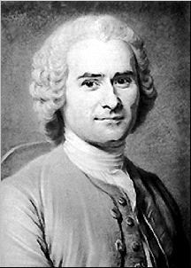
(Excerpted from The Search for Order: Landmarks of World Civilizations, Vol. 2 by Marc Anthony Meyer and from The Democracy Reader Edited by Diane Ravitch and Abigail Thernstrom)

Jean Jacques Rousseau was born in Switzerland, an orphan. After working as an apprentice engraver, he eventually ran away to Paris where he earned his living as a music teacher. In 1750 he won an essay competition for The Discourse on the Sciences and the Arts and his intellectual career began. Like many French philosophes, he was a vehement critic of the social and political order of his day. In 1762 Rousseau published The Social Contract, a masterwork of political science that describes a just society in which liberty and legality are drawn from what he terms the general will. According to Rousseau, a society consists of a collection of free and rational beings living in a given community. It is the collective action of this group that determines its contribution to social development and to humanity. Since only those individuals who are free and equal under the law can enter into a contract to form the general will, the general will becomes the moral force or authority, and in turn, the final arbiter of right and wrong.

