Overview: A graph or chart is used to present facts in visual form. They are a drawing that displays the relative sizes of numerical quantities. A graph is one of the easiest ways to compare numbers. Graphs can be used to illustrate many types of political data and are used to make facts clearer and more understandable. The likelihood of encountering a graph or chart on the multiple choice or free response sections are very high. The following are some tips to help you enhance your ability to analyze and apply the information that you will be required to respond to..

Before even attempting to answer the question do the following:
- Identify the type of data presentation that has been chosen--and why?
- Does the table, graph, or chart have a title? If it does not, can you think of one?
- Are there any labels, headings, or legends in the data visualization?
- What do the graphical entities (data points, lines, surfaces, and the like), graphical attributes (colors, size, and the like), and numerical data represent?
- What units of measurement are used? Make sure that you know which numbers are percentages or indices.
- What do the labels and other pieces of textual information used in your table, graph, or chart mean?
- Generalize or “get the picture”- Can you describe the data as accurately as possible and reduce it to a small number of useful generalizations? Divide your generalizations into "extremes" and "in-betweens." The "extremes" are (1) the starting and ending points of the time period covered, (2) the highest and lowest data points during this period, and (3) the largest and smallest changes-including significant tipping points. The "in-betweens" refer to anything else like minor fluctuations or comparisons across consecutive years within the period. Do any significant trends stand out? (i.e. gradual increases/decreases, drastic and pronounced “ups and downs”, or constant/near constant numbers)
By answering these questions, students should enhance their understanding of the graphic that they are working with.
Let’s examine some political data in different forms- For each do the following:
- Summarize the data table, chart, or graph
- Identify (two) trends/generalizations that help understand the data more clearly

#1 Independents in the US
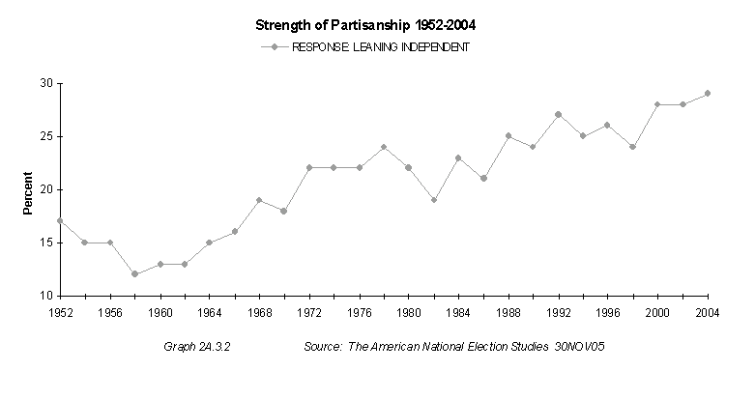

Presidential Liberalism
President | Economic | Social | Average
Roosevelt | 82.5 | 71.6 | 77.05
Johnson | 78.2 | 83.5 | 80.85
Truman | 74.6 | 74.3 | 74.45
Kennedy | 65.4 | 66.4 | 65.9
Clinton | 63.1 | 72.0 | 67.55
Carter | 60.3 | 67.0 | 63.65
Nixon | 47.7 | 44.9 | 46.3
Ford | 38.8 | 39.3 | 39.05
Eisenhower | 38.8 | 36.9 | 37.85
Bush | 33.1 | 32.8 | 32.95
Reagan | 17.6 | 18.0 | 17.8
Mean ideology scores for each president in the economic and social policy domain. Values range from 0 (most conservative) to 100 (most liberal).

#2

#3 PAC Dollars to Incumbents, Challengers, and Open Seat Candidates

Sector | Total (in millions) | To Incumbents | To Challengers | To Open Seats
Agribusiness | $19.9 | 91% | 3% | 6%
Communic/Electronics | $21.1 | 95% | 1% | 3%
Construction | $14.3 | 90% | 3% | 7%
Defense | $10.6 | 97% | 1% | 2%
Energy/Nat Resource | $22.1 | 92% | 2% | 6%
Finance/Insur/RealEst | $58.5 | 91% | 2% | 6%
Health | $39.8 | 91% | 3% | 6%
Lawyers & Lobbyists | $14.4 | 85% | 8% | 7%
Transportation | $19.5 | 93% | 2% | 6%
Misc Business | $29.3 | 89% | 3% | 8%
Labor | $59.4 | 68% | 21% | 12%
Ideology/Single-Issue | $60.9 | 57% | 24% | 19%

#4

CBS News/New York Times Poll. Oct. 27-31, 2006
"Which comes closest to your view? Gay couples should be allowed to legally marry. OR, Gay couples should be allowed to form civil unions but not legally marry. OR, There should be no legal recognition of a gay couple's relationship."
 |  | Legal  Marriage | Civil  Unions | No Legal  Recognition | Unsure
 |  | % | % | % | %
 | ALL adults | 28 | 29 | 38 | 5
 | Republicans | 12 | 29 | 54 | 5
 | Democrats | 41 | 27 | 29 | 3
 | Independents | 28 | 31 | 35 | 6
 |  |  |  |  |  | .
 | Trend:
 | 6/06 | 27 | 30 | 40 | 3
 | 2/24-28/05 | 23 | 34 | 41 | 2
 | 11/18-21/04 | 21 | 32 | 44 | 3
 | 7/11-15/04 | 28 | 31 | 38 | 3
 | 5/20-23/04 | 28 | 29 | 40 | 3
 | 3/10-14/04 | 22 | 33 | 40 | 5

