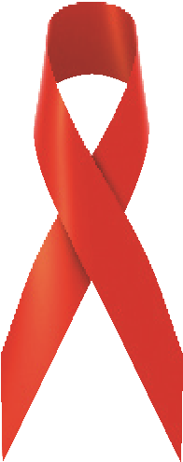
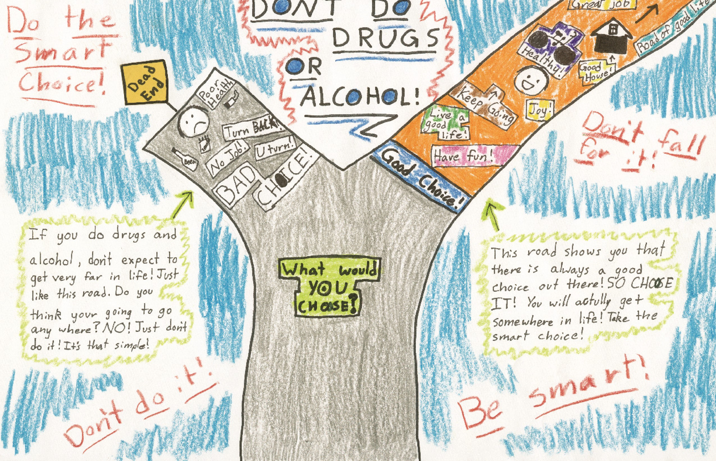

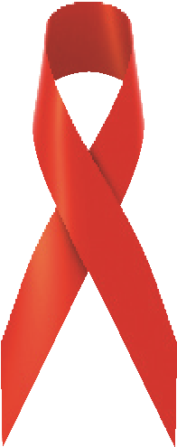
Red Ribbon Week Poster Contest

presented by HHS Student Government
In honor of one of the largest drug prevention programs in the nation, we’re kicking off our annual Red Ribbon Week Poster Contest!
Great prizes will be awarded to 1st, 2nd, & 3rd place winners! You’ll find all of the details attached.

Red Ribbon Week Poster Contest Information

Posters must be based on one of the following themes:
Drug Free is the Key
Dream, Believe, Achieve, Succeed
Show Good Character, Be Drug Free
Under the Sea says “Be Drug Free”
Don’t Monkey Around With Drugs
Say “Boo” To Drugs
Be a Star, Don’t Do Drugs
Drugs Destroy Dreams Hand-in-Hand We Stand
I Believe in Smart Choices Because...
Hop Away From Drugs
My Heroes Don’t Do Drugs

Contest Guidelines:
- Posters must be on white poster board provided
- The following PRIZES will be awarded:
- First Prize: $15 gift certificate
- Second Prize: $10 gift certificate
- Third Prize: $5 gift certificate
Winners will be selected based on creativity and message.
All posters must have the following information on the back: Student’s name, grade, and teacher’s name.
All winners will be notified by Wednesday, October 31, 2018.
All entries must be completed by Wednesday, October 31, 2018. Entries received after the deadline will not be considered.
Please give all contest entries to:
HHS Student Government
Ms. Hoetzlein-Sirman
H201

