What Some of the Current Justices Think About Stare Decisis

John Roberts at his U.S. Senate confirmation hearing, September 2005:

“The importance of settled expectations in the application of stare decisis is a very important consideration … the principles of stare decisis look at a number of factors. Settled expectations is one of them… Whether or not particular precedents have proved to be unworkable is another consideration on the other side …I do think it is a jolt to the legal system when you overrule a precedent. Precedent plays an important role in promoting stability and evenhandedness. It is not enough – and the Court has emphasized this on several occasions – that you may think the prior decision was wrongly decided. And you do look at these other factors, like settled expectations, like whether a particular precedent is workable or not, whether a precedent has been eroded by subsequent developments. All of those factors go into the determination of whether to revisit a precedent under the principles of stare decisis.”

Samuel Alito at his U.S. Senate confirmation hearing, January 2006:

“The doctrine of stare decisis is a fundamental part of our legal system. And it’s the principle that courts in general should follow their past precedents. And it’s important for a variety of reasons… it limits the power of the judiciary … it protects reliance interests …and it reflects the view that courts should respect the judgments and the wisdom that are embodied in prior judicial decisions. It’s not an inexorable command, but it is a general presumption that courts are going to follow prior precedents. I agree that, in every case in which there is prior precedent, the first issue is the issue of stare decisis. And the presumption is that the Court will follow its prior precedents. There needs to be a special justification for overruling a prior precedent.

“Factors that weigh in favor of stare decisis are things like the initial vote on the case, the length of time that the case has been on the books, whether it has been reaffirmed, whether it has been reaffirmed on stare decisis grounds, whether there has been reliance, the nature and the extent of the reliance, (and) whether the precedent has proved to be workable.

“(But) I don’t think anybody would want a rule in the area of constitutional law that said that a constitutional decision once handed down can never be overruled.”

Most commentators think that Justice Thomas is probably the individual on the current Court who gives least weight to precedent, particularly if he thinks the precedent was wrongly decided in the first place. Here’s an excerpt from his concurring opinion in Randall v. Sorrell, the campaign finance case from Vermont decided in June 2006:

“I continue to believe that Buckley (Buckley v. Valeo is the precedent that was applied by the majority in deciding Randall) provides insufficient protection to political speech, the core of the First Amendment. The illegitimacy of Buckley is further underscored by the continuing inability of the Court to apply Buckley in a coherent and principled fashion. As a result stare decisis should provide no bar to overruling Buckley and replacing it with a standard faithful to the First Amendment.”

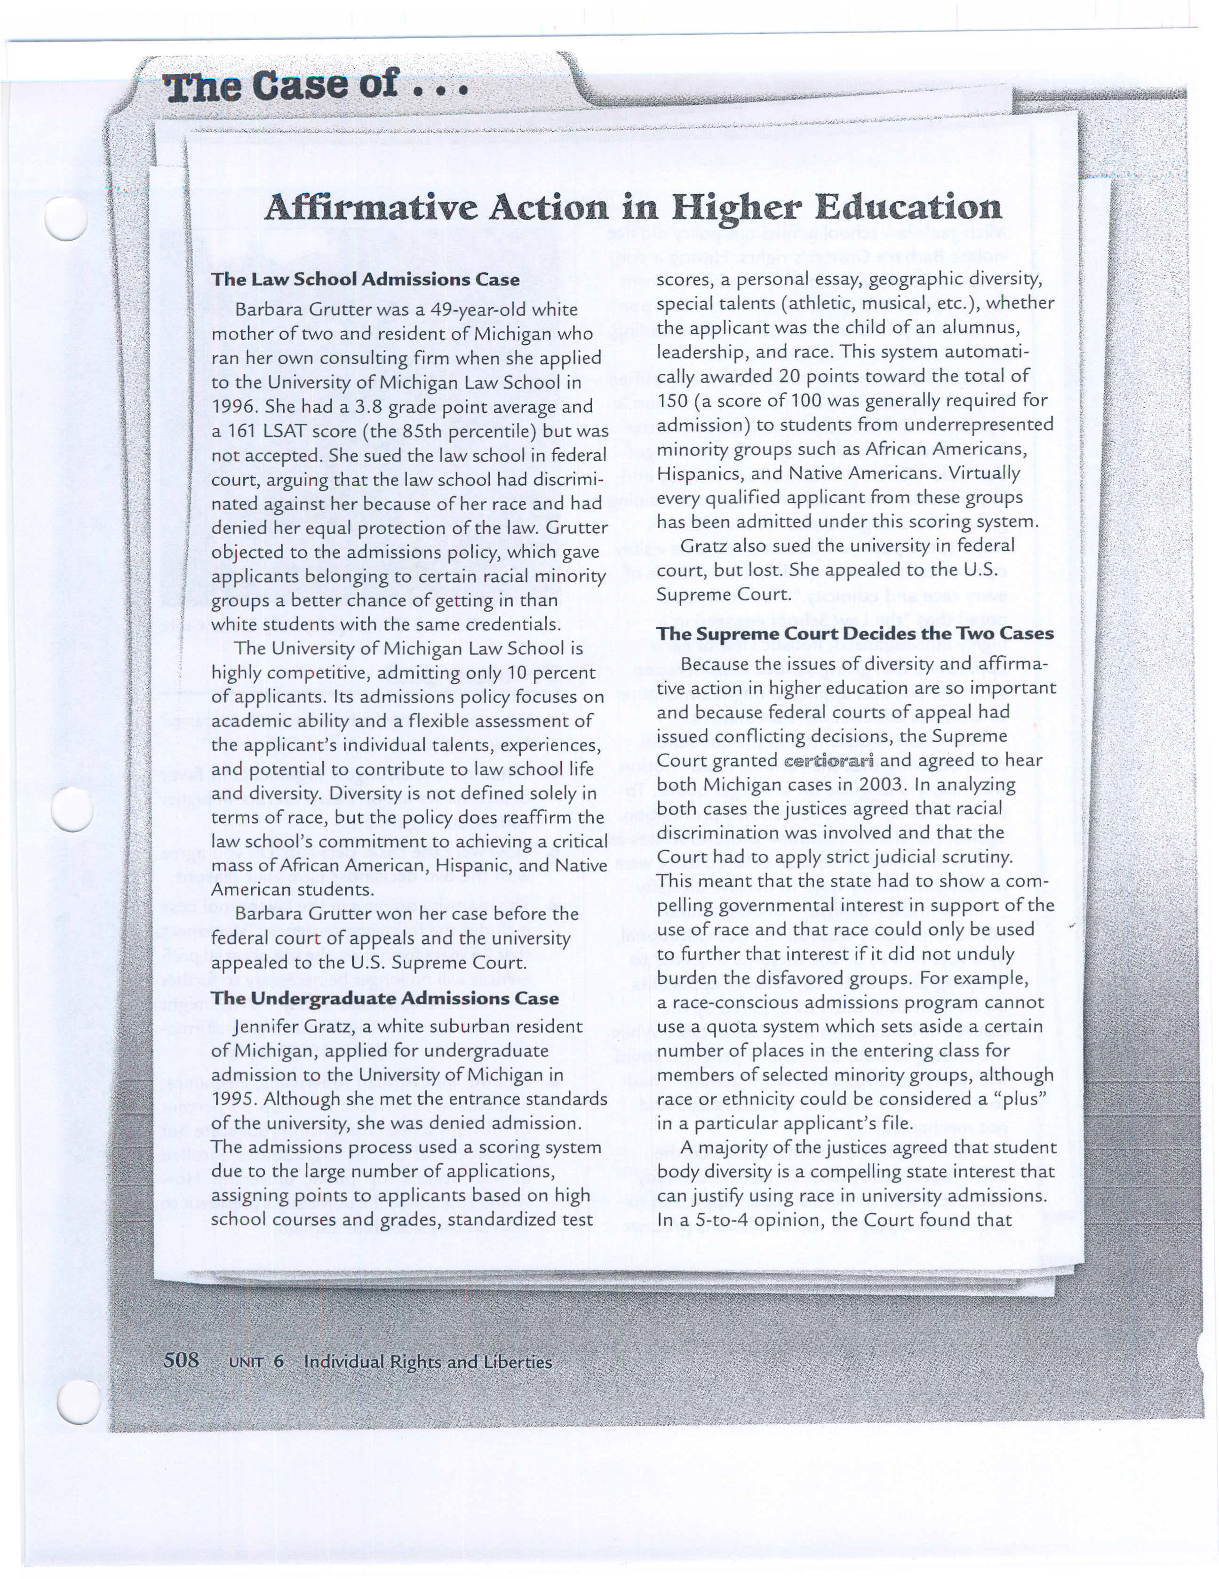

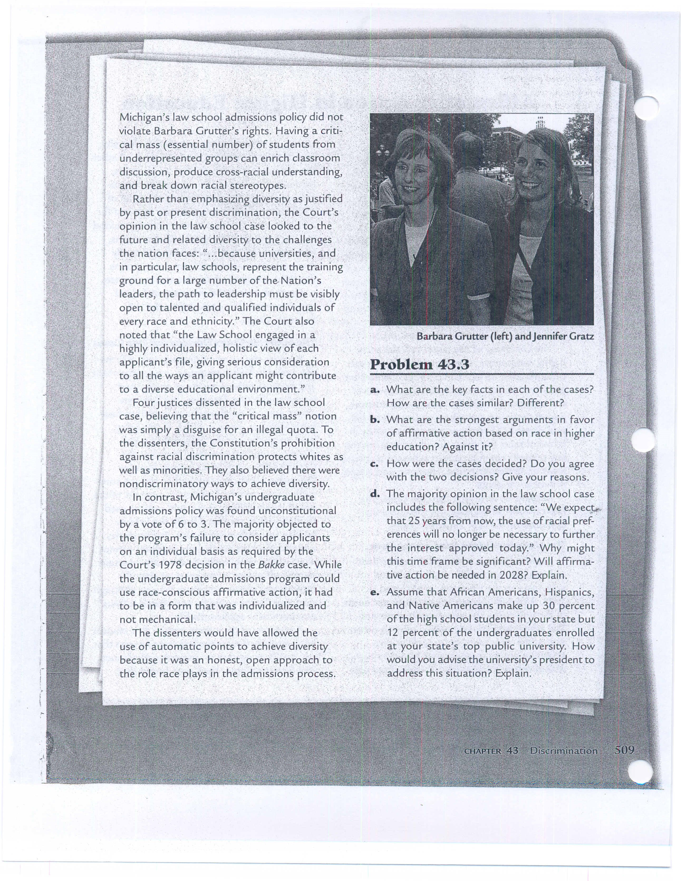

Parents Involved in Community Schools v. Seattle School District, et al.
Argument date – December 4, 2006
The Seattle School District operates ten four-year public high schools. The District has an
“Open Choice” plan that allows incoming ninth graders to choose to attend any of those schools. Five of the ten schools are typically oversubscribed, meaning that more students choose to attend these schools than the schools can accommodate. When a school is oversubscribed, the District makes its assignment decision using a series of four tie-breakers.
The first tie-breaker provides admission priority to students who have a sibling already enrolled in the school selected. The second tie-breaker involves race. The District’s overall enrollment is
approximately 60% nonwhite and 40% white. The District will admit a student to an oversubscribed school only if his or her race does not contribute to racial imbalance in that school A school is considered racially imbalanced if it has fewer than 25% white students or more than 75% nonwhite students (i.e., a range of within 15% of the district’s overall racial profile). The third tie-breaker is based on distance from the school and applies when an oversubscribed school is racially balanced or when the race-based tiebreaker brings a previously imbalanced school within the approved racial range. In those instances, students who live closest to the school are admitted ahead of those who live farther away. The fourth tie-breaker is a lottery, and it is rarely used.
For the 2000 – 2001 school year, the district estimates that approximately 15 – 20% of the students’ school assignments were made using the tie-breakers. The District’s assignment plan was designed to combine the benefit of choice with the educational and social benefits of a racially diverse learning environment, avoiding the racial isolation found in Seattle’s housing pattern. The assignment plan does not operate to reduce racial isolation in under-subscribed schools, which tend to be the most racially isolated schools in Seattle.
A group of parents whose children were not assigned to their high schools of choice challenged the legality of the District’s race-based student assignment plan. They argued that the plan involved racial balancing and that this is prohibited by the Fourteenth Amendment’s Equal Protection Clause. Over a period of four years, there were a number of federal and state court decisions in this case. In 2005, a divided en banc (7 – 4) panel of the Ninth Circuit found that the Seattle assignment plan was not a violation of the Equal Protection Clause. The parents appealed to the Supreme Court of the United States and certiorari was granted.
How should the Seattle case be decided? Give your reasons. Consider the Court’s decisions in the two affirmative action in higher education cases from 2003. How do these decisions relate to the Seattle case?

