The Twenty-First Century Tea Party Movement
By Brent Scher
On December 16, 1773, colonists in Boston staged a protest against the British government in response to the Tea Act. The Tea Act forced the colonists to buy tea only from the British East India Company, extending the company’s monopoly on tea to the colonies. The colonists saw this act as a new tax being imposed on them by the British, which they saw as unjust because they believed that only their own elected representatives had the right to tax them. There was resistance to the Tea Act in port cities throughout the colonies. In New York and Philadelphia, the ships carrying the tea were sent back to Britain without unloading any of the crates. In Boston, however, a group of colonists boarded the ships and threw all of the crates overboard into the Boston Harbor. This iconic protest came to be known as the Boston Tea Party, and became a symbol for the American Revolution.
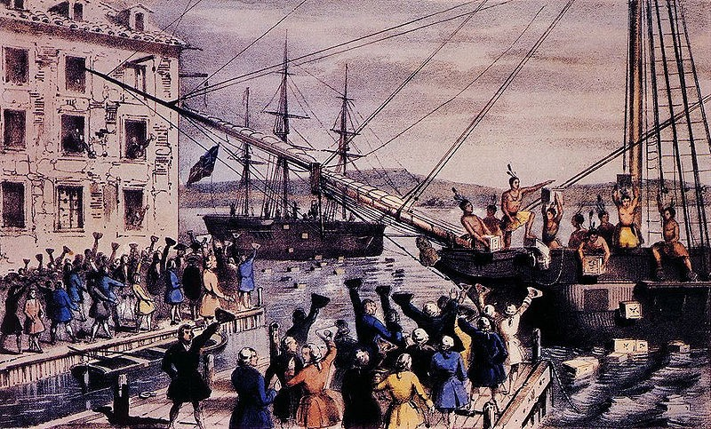
1846 Lithograph by Nathaniel Currier depicting the 1773 Boston Tea Party

Today the United States is experiencing a new brand of Tea Party that is taking the country by storm. Beginning in February 2009, citizens began to come together for Tea Party gatherings in cities and towns across the United States. These protests were for the most part organized by average Americans. Keli Carender, a Seattle teacher in her thirties whose political activity extended only as far as writing a political blog, is credited with organizing some of the first Tea Parties. Before they were even called Tea Parties, she organized a February 16, 2009 protest, called “the porkulus,” in response to the Obama administration’s $787 billion economic stimulus package. American political analysts Scott Rasmussen and Douglas Schoen describe this early protest as “a spontaneous, grassroots rebellion, driven by anger and fear of the implications of President Barack Obama’s excessive government spending initiatives and frustration with a seemingly out-of-touch and ineffective government.” In only two years, the Tea Party message has caught on. An April 2010 Rasmussen Reports poll claimed that there were more Americans who agreed with the Tea Party on the major issues, than Americans who agreed with President Obama on the same issues.
The Tea Party movement was not simply a response to the stimulus bill. The Tea Party was motivated by the Unites States’ response to the economic crisis during the administrations of both President George W. Bush and President Obama. The movement gained both its name and much momentum from a live telecast by CNBC financial analyst Rick Santelli on the floor of the Chicago Mercantile Exchange on February 19, 2009. In what has now become an infamous rant, Santelli voiced his opposition to the financial bailouts of the failing sectors of the United States’ economy by the federal government. He spoke directly to American’s who felt that their tax dollars were being spent irresponsibly in order to bailout those that didn’t deserve to be bailed out. Santelli ended his rant by calling for everyone who agreed with him to meet for a Chicago Tea Party. Although not many were watching this live telecast, it became an instant internet sensation. It has been viewed over one million times on YouTube.
Within hours, Tea Party organizing websites sprouted up across the internet. The use of social networking websites such as YouTube and Facebook played an important role in the rise of a group like the Tea Party. “There would be no Tea Party had there not been a fundamental transformation of America’s media landscape,” write Schoen and Rasmussen. “It has been a ground-up movement, spread virally, blog by blog, website to website, beneath the surface.” What began as independently organized grassroots protests, has turned into the most vibrant political force in modern American politics. The movement grew at an outstanding rate. On April 15, 2009, just about two months after Carender’s initial “porkulus” protest, tea parties were held in honor of Tax Day in over 750 cities and towns across the country.
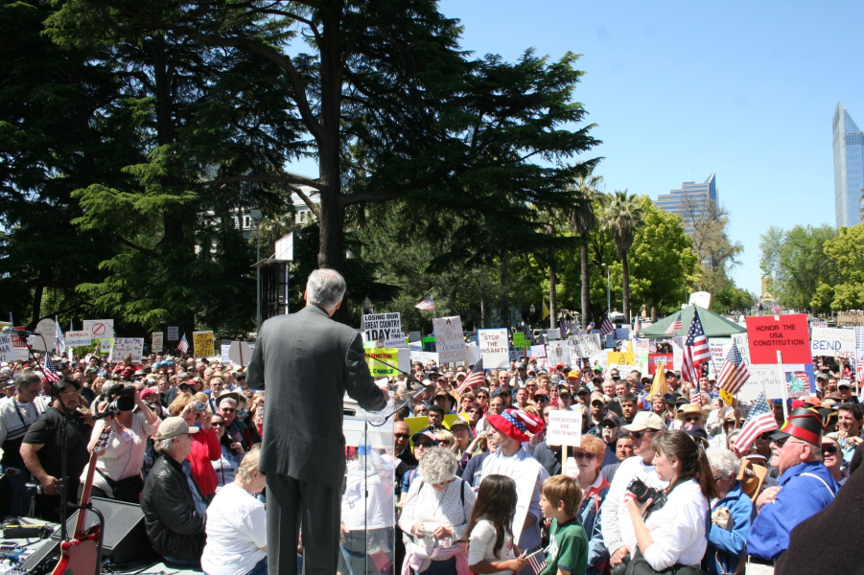
April 15, 2009, Tax Day Tea Party protest at the State Capitol, Sacramento, CA

The Tea Party is composed of the large portion of the American electorate that is dissatisfied with the established political order. Tea Partiers see themselves as mainstream Americans that have been forgotten by the political elite. The political elite is defined by Rasmussen and Schoen as a self-selecting group of influencers from business, government, academia, and the media who occupy the most prestigious institutional positions in American society and in power centers in Washington. Tea Party members see the leadership of both the Democrats and the Republicans as members of the political elite, and think that both parties have let the American people down. The Tea Party is made up of voters who believe that the voter has lost its say, and want the electorate to be let back into the decision-making process. The main principles that unite Tea Party supporters are fiscal responsibility, limited government, and a strict adherence to the original meaning of the Constitution. A call for fiscal responsibility is a call for the government to have a balanced budget, meaning that government spending cannot exceed government revenue, so as to avoid a budget deficit. The principle of limited government means that the work of the government should be constrained by the powers designated to it in the U.S. Constitution and that it should be less involved with the everyday lives of Americans. Strict adherence to the original meaning of the Constitution, commonly referred to as strict construction, entails an attempt to determine precisely what the Founding Fathers intended when writing the document in 1787 and strictly following the Constitution according to that understanding of it.
This set of simple principles has the ability to mobilize a wide range of the electorate that may disagree on some issues, but can agree on those core ideals. Rasmussen and Schoen explain that the Tea Party is composed of three distinct groups: 1) political newcomers who have been mobilized by a spontaneous and significant degree of outrage with the status quo, 2) independents who feel betrayed by both the Republicans and Democrats for the government’s current state, and 3) core Republicans who feel like they no longer have a home in the modern Republican Party.
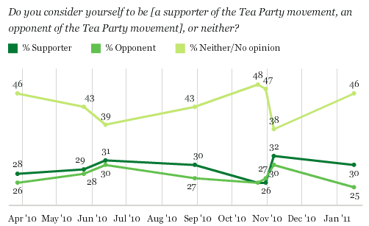
Source: Gallup, January 31, 2011
The Tea Party is a very unique movement in American political history. While in some ways it is similar to other third parties in history, the Tea Party is different in many ways as well. One way that it is different is in the way that it is organized. There is no central leadership for the Tea Party, and there is no central party headquarters. The power of the movement remains in the local Tea Party organizations. The Tea Party has already obtained the level of support needed to be a politically viable third party. Despite this support, it is not clear whether the Tea Partiers want to be a third party. A March 2010 study by the Sam Adams Alliance revealed that 86 percent of Tea Party supporters oppose the formation of a third party. Rather than forming a third party, the Tea Party has instead turned to driving the direction and the agenda of the Republican Party towards Tea Party ideals. Tea Party politicians are predominantly members of the Republican Party. For example, there is now a Tea Party Caucus in both the U.S. Senate and the House of Representatives, but the Caucuses in both the Senate and the House are composed entirely of members of the Republican Party.
This dynamic has raised significant concerns within the Tea Party that the Republican Party will try and co-opt the Tea Party message. Florida Senator Marco Rubio, who is strongly supported by the Tea Party, refused to join the Tea Party caucus in the Senate because he thought that it would ruin what the Tea Party stands for. “Really what I think the strength of the Tea Party is that it comes from the grass roots,” said Rubio, “That's the strength of the Tea Party: that it's not a political organization run by people out of Washington. My concern is a Tea Party caucus could intrude on that.”
Party Affiliation of Tea Party Supporters
Democrat | 4%
Republican | 44%
Independent | 52%

Source: CNN Poll, February 2010

The Tea Party was a force to be reckoned with in the 2010 midterm elections, and its influence will certainly still be present in the 2012 elections. Not only did Tea Party candidates find success in the 2010 midterm elections, but the Tea Party was also a crucial ground-level political force that mobilized many new voters that helped elect Republican candidates across the country. The rise of the Tea Party can also cause a lot of problems for the Republicans by attracting voters away from the Republicans. A February 2010 CNN Poll showed that more Tea Party supporters identified themselves as Republicans than Democrats, meaning that a Tea Party candidate would likely draw votes away from Republicans only. They also conducted polls to directly illustrate this point. When respondents were asked in a generic ballot test whether they planned to vote for a Democrat or a Republican in the upcoming 2010 elections, it was a tie at 46 percent. When a Tea Party candidate was thrown into the mix, the Democrat came out on top by 14 percent because 16 percent of the respondents said that they would support the Tea Party.

2010 Generic Ballot Test,
Democrat or Republican?
Democrat | 46%
Republican | 46%

2010 Generic Ballot Test,
Democrat, Republican, or Tea Party?
Democrat | 46%
Republican | 32%
Tea Party | 16%

Source: CNN Poll, February 2010
The Tea Party has been effective in molding the agenda of the Republican Party since the 2010 elections. The Tea Party is shaping the national debate. In a study conducted by the Sam Adams Alliance, Tea Party supporters were asked what issue they considered to be “very important,” and 92 percent said the “budget.” The growth of the Tea Party forced the two parties to focus on spending and managing the country’s massive deficit. The budget has now become the central issue in the American political arena. The overwhelming support for the Tea Party has forced the political establishment to address the Tea Party grievances. The political elite that the Tea Party viewed as unresponsive to their needs are now being forced to provide answers to the Tea Party’s questions.
Given the movement’s unpredictable growth since February 2009 and the broad support that the movement has already obtained, it is hard to say what the future will hold for the Tea Party. The Tea Party movement has completely transformed the political landscape from what it was just a few years ago. In just two years, the Tea Party has become a movement that makes its voice heard and also has the ability to influence policy. The rise of the Tea Party not only has changed the American political landscape, but it also has shown the power that grassroots movements can have in the future of American politics.
Sources
Scott Rasmussen and Douglas Schoen, Mad as Hell
Miami Herald, “Senator Marco Rubio Says Tea Party Caucus Not Needed,” http://www.miamiherald.com/2011/01/26/2035128/sen-marco-rubio-says-tea-party.html#ixzz1FCPEhQLv
Thomson, Alex, A Glossary of US Politics & Government

The Tea Set
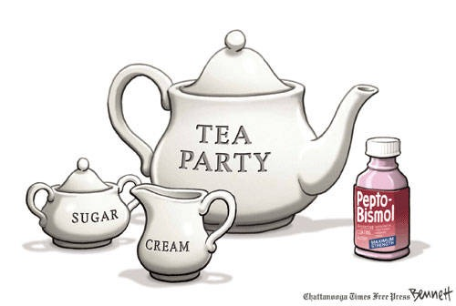

http://politicalhumor.about.com/od/politicalcartoons/ig/Tea-Party-Cartoons/The-Tea-Set.htm

